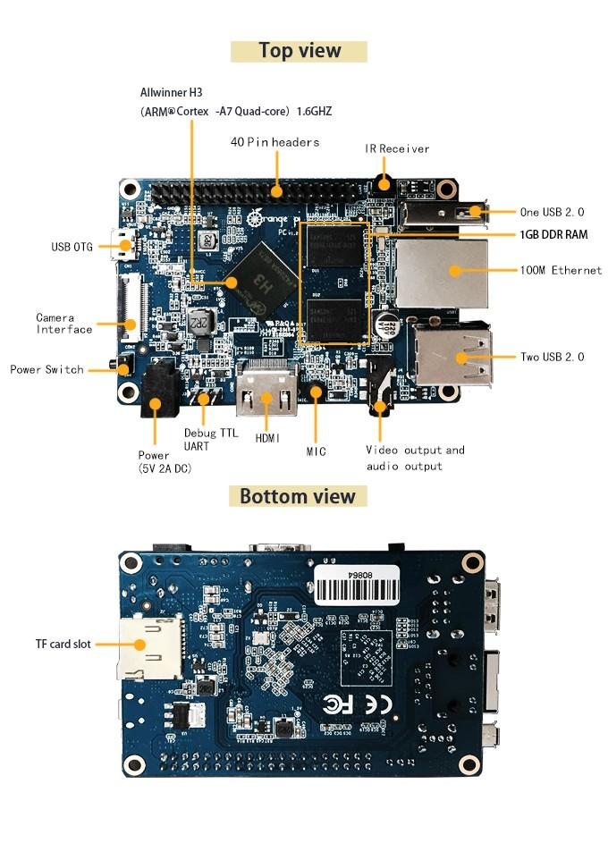

# **Orange Pi PC ubuntu linux and android mini PC Beyond and Compatible with Raspberry Pi 2**

### **What’s Orange Pi PC?**

It’s an open-source single-board computer. It can run Android 4.4, Ubuntu, Debian, Rasberry Pi Image. It uses the AllWinner H3 SoC, and has 1GB DDR3 SDRAM

### **What can I do with Orange Pi PC?**

Build…

* A computer
* A wireless server
* Games
* Music and sounds
* HD video
* A speaker
* Android
* Scratch
* Pretty much anything else, because Orange Pi is open source

### **Who’s it for?**

Orange Pi PC is for anyone who wants to start creating with technology – not just consuming it. It's a simple, fun, useful tool that you can use to start taking control of the world around you. Sale contact:

zhao_stevenAT263.net (Consulting service)

Attention Twitter:orangepixunlong

skype: zhaoyifan_steven

Facebook: +8613632793025

Google+:steven.zhaoyifanATgmail.com

<http://www.orangepi.org/orangepipc/>

<http://www.orangepi.org/>